**University of Michigan – Dearborn**

**CIS 150 – Computer Science 1**

**Lab# 10**

**Professor Bacha**

Demetrius Johnson

[meech@umich.edu](mailto:meech@umich.edu)

March 31, 2020

**Table Content**

Contents

Question 1 3

Test Cases 3

Source Code – see LAB10Q1.cpp 3

Screenshots 3

Question 2 4

Test Cases 4

Source Code – see LAB10Q2.cpp 4

LAB10Q2 – text files used for input 5

Screenshots 6

# Question 1

## Test Cases

|  |  |  |  |  |  |
| --- | --- | --- | --- | --- | --- |
| Test # | Valid / Invalid Data | Description of test | Input Value | Actual Output | Test Pass / Fail |
| 1 | valid | Ensure code compiles successfully | See screenshot | See screenshot | pass |
|  |  |  |  |  |  |
|  |  |  |  |  |  |
|  |  |  |  |  |  |

## Source Code – see LAB10Q1.cpp

## Screenshots

TEST 1

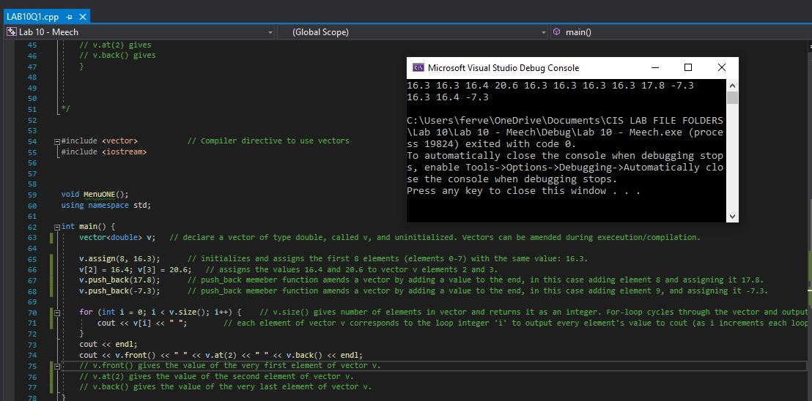

# Question 2

## Test Cases

|  |  |  |  |  |  |
| --- | --- | --- | --- | --- | --- |
| Test # | Valid / Invalid Data | Description of test | Input Value | Actual Output | Test Pass / Fail |
| 1 | valid | Input a file that could not be found/opened | False file name: see screenshot | See screenshot | pass |
| 2 | valid | Input a file, see if data is analyzed correctly | See text file input:  temps-1.txt | See screenshot | pass |
| 3 | valid | Input a file, see if data is analyzed correctly | See text file input:  temps-2.txt | See screenshot | pass |
| 4 | valid | Input a file, see if data is analyzed correctly | See text file input:  temps-3.txt | See screenshot | pass |
| 5 |  | Input a file, see if data is analyzed correctly – no frozen days | See text file input:  temps-allAboveAverage.txt | See screenshot | pass |
| 6 |  | Input a file, see if data is analyzed correctly – no data in file | See text file input:  temps-emptyfile.txt | See screenshot | pass |

## Source Code – see LAB10Q2.cpp

## LAB10Q2 – text files used for input

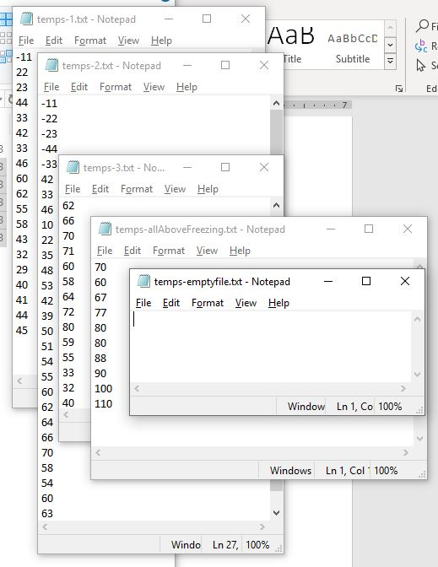

## Screenshots

TEST 1

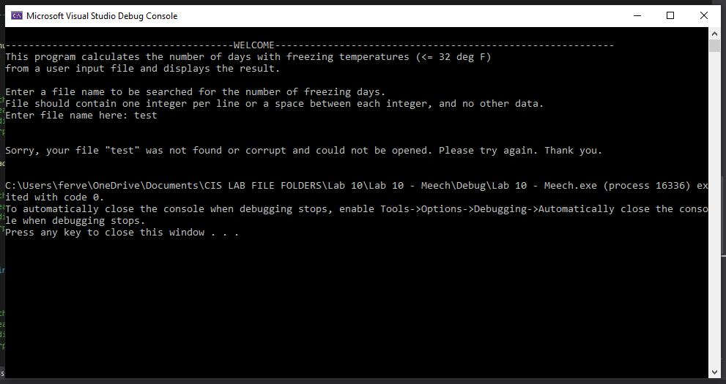

TEST 2

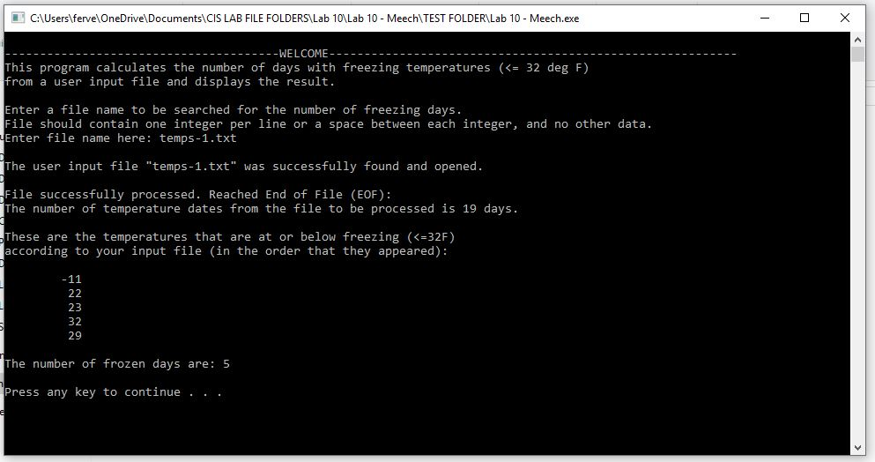

TEST 3

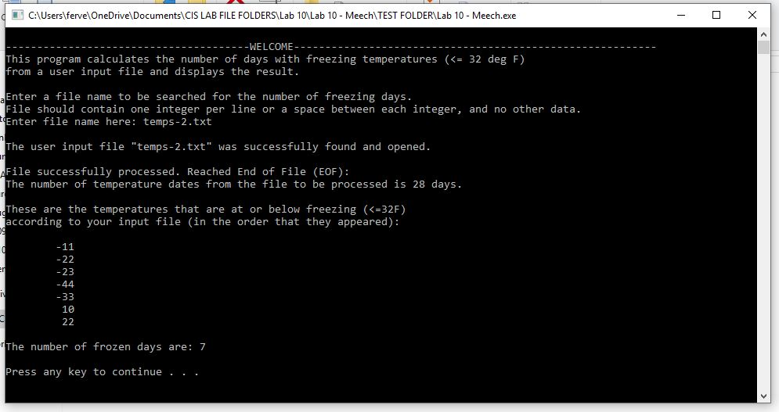

TEST 4

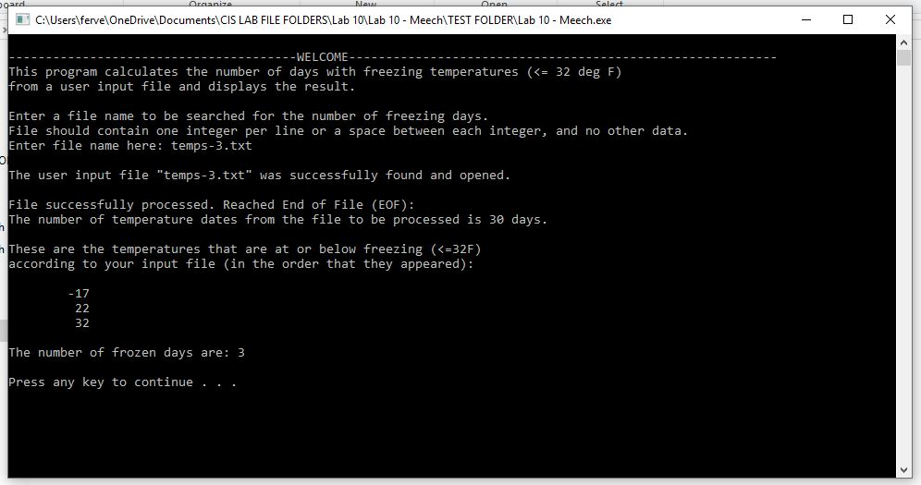

TEST 5

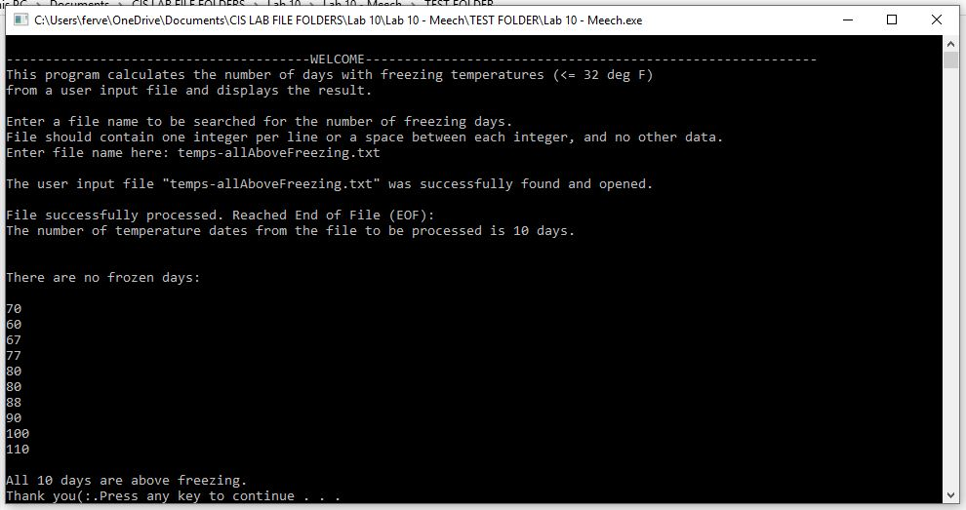

TEST 6

